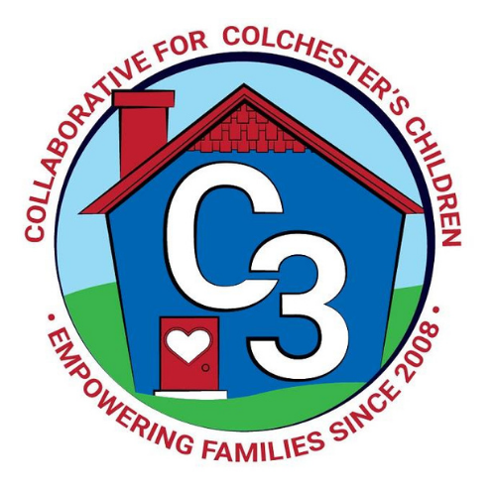**Colchester School Readiness Council**

June 6, 2024

Google Meet/Virtual Only

**Time: 5:30 – 7:00 p.m.**

**Meeting Minutes**

**Attendance:** Cindy Praisner, Laurie Buyniski, Kristina Swain, Lindsay Therian, Lisette Stone

**McKinney-Vento Homeless Update:** No update.

**OEC/SR Updates:** C. Praisner shared that the State of CT OEC is working to make changes through the Early Start CT initiative to streamline and simplify processes for SR programs, standardize fees, and change the format and/or structure of local governance bodies that oversee School Readiness funds. Programs may eventually contract directly with the OEC. A powerpoint with more details will be shared via email with council members. An information session for providers will take place on June 13th, a representative from Castle is planning to attend.

**SR Budget Update:** C. Praisner reported that enrollment funds have been submitted for the quarter. Some funds have been reallocated, tuition payments are on track. The funds for C. Praisner’s salary needs to be adjusted through the Town Hall finance department.

Peace at Home Parenting contract will not be renewed due to low participation, despite efforts to promote and engage families. Current program will end on June 30th.

C3 has purchased 75 seats in the online Conscious Discipline training course ‘Responding to Anger & Rage’. Parents and Staff can take this program; it is 9 hours online, self-paced.

There is still space in the ‘Handling Upset’ course which ends September 25th. Council members should reach out to C. Praisner if you/staff would like to take either course.

**SR Program Monitoring:** C. Praisner informed the council that all observations have been completed and that reports will be coming from J. Lenares soon.

**SR Spaces for 24-25:** C. Praisner reported that there are 9 Part Day spaces still open. Continuing to work on registration with families that have been accepted into slots. Over income families will need to wait until August 1st to be placed per SR policy. Council members discussed ways to promote remaining slots such as sharing information at Farmer’s markets, updating SR flyer, and sharing at Library programs during the summer.

**Council Participation in 24-25:** C. Praisner reviewed the council members that will continue for the 24-25 school year. Jennifer Rummel and Kaitlin Cassidy will remain as co-chairs. The council discussed the potential of having daytime meetings. T. Kessing will become health representative and likely available virtually during school day, Cynthia West will continue as business representative. There are currently five parents; however, the shift to a new time may make it difficult for them to attend daytime meetings. Castle has offered to trade off members to attend meetings so that there is consistent representation. C. Praisner discussed holding C3 and SR meetings concurrently, as it will be more cohesive, reduce the amount of overlap and be more efficient.

**Sparkler Updates:** Council members discussed some recent changes to the app and how programs are notified of results, follow up goes to the program if the program code is used by the family. Programs need to release results in order for families to see them. This is a change to the original process.

**Family Fee Waiver request**: A hardship request was received; however, there were not enough council members in attendance to vote. C. Praisner will send via email after meeting.

**2024-2025 Meeting Dates**

TBD

Submitted by:

Laurie Buyniski, Program Coordinator