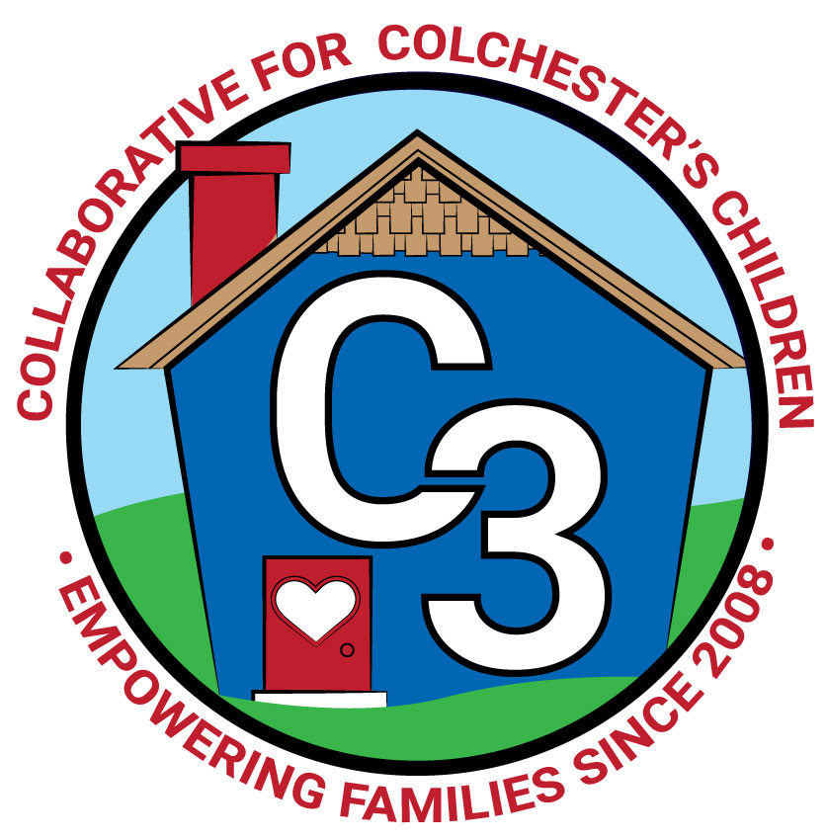

**COLLABORATIVE FOR COLCHESTER’S CHILDREN**

**January 14, 2025**

**Leadership Work Group/School Readiness Meeting**

**Cragin Memorial Library**

**9:00-10:30AM**

**Attendance:** Cindy Praisner, Laurie Buyniski, Regina Brady, Julia Lash, Jennifer Rummel, Kaitlin Cassidy, Rosemary Kelley, Kate Byroade, Meaghan Amado, Jamie Girvin, Nicole Beauchamp, Sharon Wilinski

**Partner Updates**

Castle - N. Beauchamp reported that strategic planning with the board will begin soon. In the process of managing enrollment for Fall . A Trivia Night & SIlent Auction fundraiser will be held on March 15th. Tools from Conscious Discipline have been installed in the Calm/Regulation room to provide supportive activities for students.

CPS - M. Amado reported CES has updated the website with information for incoming Kindergarten families, including Story Hour schedule (Feb 25, March 20, April 22 at 11:30-12), as well as Preschool Lottery, and Kindergarten waiver process. Kindergarten waiver request forms must be submitted by Feb 28, and assessments will take place on March 18th. C3 will send notice of Lottery application and Kindergarten info out to families.

Cragin—K. Byroade shared that library hours are now extended on Tuesday until 8PM. Summer reading planning has begun. In the process of strategic planning, in collaboration with 5 other libraries to share the services of a consultant. Finding that people are asking for things that the library already offers, and therefore determining best ways to communicate so that patrons know what is available.

**Universal Newborn Home Visiting Program**

R. Brady shared information about the new Universal Home Visiting program through TVCCA. It is currently in the pilot stage in five towns. Colchester will be part of phase 2. The program supports families who deliver their baby at Backus Hospital with an RN visit 1-3 times within 14-34 days postpartum. An assessment of the mom and baby will include physical and mental health in hopes of reducing ER visits. There are no income guidelines, all are eligible for this service. The initiative comes from the governor’s office to meet the needs of families.

**TVCCA**- There has been an increase in the number of WIC families over the past year. Also, TVCCA is managing new mandates for HeadStart/EHS.

**Parent Updates -** J. Lash shared an update from CCNS regarding enrollment for the Fall, Open House will take place on Feb 1st at 10-12pm, in person registration will be held on Feb 8th.

**Parent Council/OEC Ambassadors** - Julia Lash and Rosemary Kelley reported that a comprehensive postpartum regional resource guide is in the works. Looking for support from Colchester is Kind group to support an initiative to help new parents. Also working on creating a diaper supply/emergency kit for families who visit Cragin and need supplies in a pinch. Region 3 joint Parent Ambassador & Cabinet meeting will take place on Jan 22. The Holiday Homecoming event was successful, handed out 200 bags of craft kits. Next meeting will take place on Jan 27th, planning goals and next steps. The Color House fundraiser is scheduled for Jan 20th. K. Cassidy offered to promote/discuss postpartum support in Baby & Me class. Friends of the Library will be donating a storage organizer for the diaper supply/emergency kit.

**McKinney-Vento Homeless Update** - No update.

**OEC/SR Updates**

C. Praisner has been notified that LGP identification will begin in March. Some changes to the process include funds going directly to the programs to improve efficiency. Liaison will focus efforts on coaching and community outreach. Council discussed the current situation and decided to move forward using last year's application process. Members agreed that Early Start CT (formerly School Readiness) application will be released to families by mid-February as planned.

**Local SR Updates**

All slots are currently full.

Annual cost of care for 2024-25- Castle SD $203/week, CES SD $605/month, PD $300/month.

**C3 General Updates and Events**

C. Praisner reported that the budget is on track for spending.

A new Sparkler Regional Coordinator will be working to engage communities, prenatal function of the app is now available. Cragin has been chosen by the state to integrate the app into Storytime. The state code will be used to connect families to services via 211.

C. Praisner, L. Buyniski and J. Lenares are taking part in a professional development course, Circle of Security extension training called The Human Condition, A Journey through the Core Sensitivities. COS is being offered through St. Francis on Thursdays, virtually.

Currently running Winter sessions of Joyful Noises, Baby & Me, Stroller Walks. Parent Education includes Love Languages Workshop (2/10), PEP (low enrollment), FLIP IT (end of Feb), Brain Behavior Connection - Dads, CD Refresher.

**Budget Review -** C. Praisner reviewed the budget and noted adjustments to pay for additional SEL Active Calming Walls. SR monitoring for the Fall was completed by C. Praisner.

**Global Day of Unplugging -** C. Praisner shared with council members that the Global Day of Unplugging is March 7-8. Planning to organize an effort around this in collaboration with Parks & Rec, YSS and Cragin. Cragin has planned a book sale and Storytime with Ariel on March 8th.

**The Parents Aren’t Alright**

C. Praisner showed the US Surgeon General’s Advisory on the Mental Health and Well-Being of Parents. Council members also discussed the book, The Anxious Generation, as some CES staff have recently participated in a book club discussion. A Parent presentation will take place during the Digital Learning Day event on February 20th at JJIS. Goal is to bring more awareness to Parents/Caregivers on the use of devices and how to handle challenges as well as the connection to mental health and screen time.

**Upcoming Meeting Dates for 2024-2025**

Feb 25

April 1

May 6

Submitted by:

Laurie Buyniski, Program Coordinator