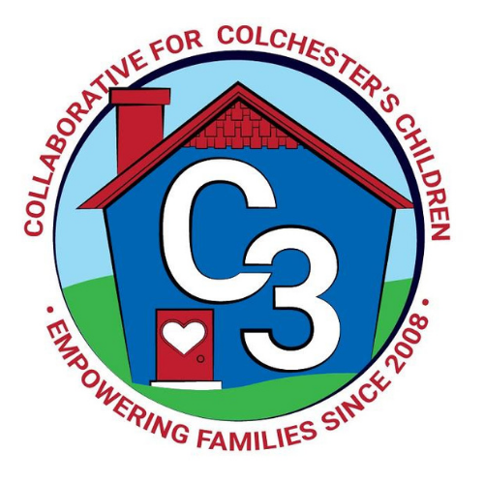**Colchester School Readiness Council**

April 18, 2024

CES Conference Room/Google Meet

**Time: 5:30 – 7:00 p.m.**

**Meeting Minutes**

**Attendance:** Cindy Praisner, Laurie Buyniski, Kristina Swain, Jennifer Lombardo, Meghan Amado, Jennifer Rummel, Lindsay Therian, Kaitlin Cassidy, Eve Hurley, Judy O’Meara, Lisette Stone.

**McKinney-Vento Homeless Update:** E.Hurley reported no new developments.

**OEC/SR Updates:** C. Praisner shared that there may be changes to the requirement for local governance partners, as legislation could impact the logistics of how School Readiness Councils operate in the future. SRC could become part of the C3 Leadership Work Group, as a subcommittee. Will know more about the changes after the legislative session ends May 8th.

**SR Budget Update:** C. Praisner requested that programs send an invoice to cover the cost of subs for professional development training. A proposal for revisions to the budget was discussed. Revisions were accepted as proposed.

**Current SR Classroom Status**: C. Praisner reported that the programs are at full enrollment.

**SR Program Monitoring:** C. Praisner reported that Spring monitoring and coaching is on track, planning for a ½ hour observation and ½ hour interview portion of TPOT.

**Kindergarten Waiver Update:** J. O’Meara reported to the council that the results of the waiver screening have been distributed to families, which included the decision and scores. Explained that the change in Kindergarten start date has been difficult for families due to the financial impact; however, the law is in place to ensure that kids are developmentally ready. In addition to district use of screening tools, local providers also offered input on student readiness.

**Sparkler Update:** C. Praisner shared that Julia Lash will now be taking the place of Sparkler Coordinator as Kaitlin Cassidy has been covering Joyful Noises for the Spring session. Castle will have new families complete Sparkler screening in May/June. CECP has asked incoming lottery students to complete as well. This should really help support the use of Sparkler in Colchester.

**SR RFP FY25:** C. Praisner reviewed the process for RFP for FY25 with council members including membership responsibilities and requirements. Discussed the roles of parents, workforce and business representatives. The council did not reopen the application to new programs because there were no new funds available. Town and Country had expressed interest but C. Praisner contacted them to let them know that the process would not be opened this year. Returning students can stay where they are, and if they want to change, they can apply to do so. First round of applications will be reviewed and scored on Friday, April 26th by C. Praisner, M. Amado and L. Therian. Council approved the submission of the FY25 RFA for $250,425 and QE for $3881.

**Financial Assistance Requests:** Council members discussed the recent increase in the number of families requesting Financial Assistance/Hardship. The increase in requests is likely due to the increase in costs for the programs. It was decided, at this time, that there would be no change in the required documentation when a family submits a request.

**2023-2024 Meeting Dates**

Jun 6, 2024

Submitted by:

Laurie Buyniski, Program Coordinator