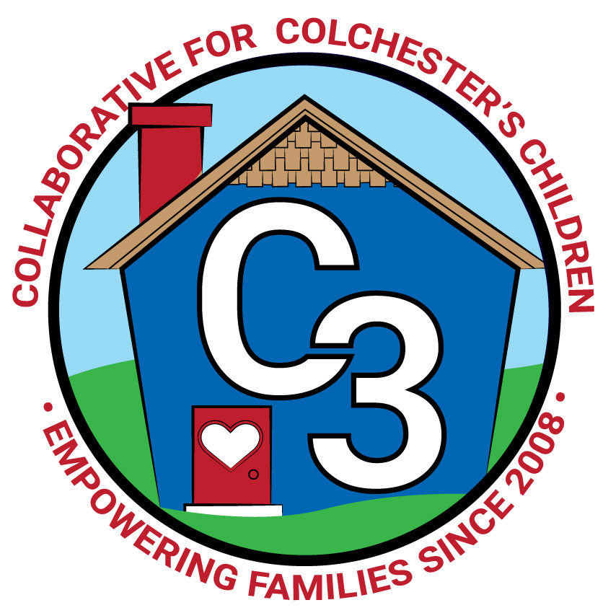

**COLLABORATIVE FOR COLCHESTER’S CHILDREN**

**December 3, 2024**

**Leadership Work Group/School Readiness Meeting**

**Cragin Memorial Library**

**9:00-10:30AM**

**Attendance:** Cindy Praisner, Laurie Buyniski, Julia Lash, Jennifer Rummel, Kaitlin Cassidy, Sarah Russell, Rosemary Kelley, Dan Sullivan, Eve Hurley, Kate Byroade, Judy O’Meara, Jamie Shannon, Nicole Beauchamp, Gabriela Koc (guest, Office of State Treasurer)

**Partner Updates**

Castle - CPR bystander class was held last month, training more than 35 participants in the community. Castle will receive a grant-funded AED as a result of hosting the class. Planning for the Winter Wonderland event which includes a visit from Santa and craft activities. This event is open to the public. N. Beauchamp also reported that the RFA for School Readiness has been completed and strategic planning is underway.

CPS - J. O’Meara reported that School Readiness RFA has been completed; some questions included those about assessment, enrollment strategy and staff retention. Program administrators are considering the future needs of families, requested to convert some PD in order to increase the number of SD slots to make up for change in rate for Part Day spaces..

Cragin—K. Byroade shared that Kindergarten visits are underway. All Kindergarten students in the district attend a field trip to the library, where they watch the Piggy Opera, make a craft, and obtain a library card to check out a book. The library is in the process of strategic planning, working with a consultant. Surveys were conducted of parents, teens, and school principals, among others.

**McKinney-Vento Homeless Update** - E. Hurley provided the council members with a brief overview of the policy which supports families with school-aged children, who may be homeless or home insecure, with meals and transportation in the hopes of keeping children in the school district whenever possible. Nothing new to report.

**OEC/SR Updates**

Council members discussed potential changes in the SR application process based on decisions made by the state and local partners. The SR Council will no longer be involved in submitting the application for School Readiness funds. The State has not released the application for Local Governance Partners yet.

**Parent Updates**

Parent Council/OEC Ambassadors - Julia Lash and Rosemary Kelley discussed goals of recruiting new members to the Parent Council. Events such as Trunk or Treat and Holiday Homecoming help spread the word about C3 and volunteer opportunities. OEC meeting took place on November 6th, the next meeting is scheduled for January 22nd. The Community/Parent Cafe event was a success, covering the topic of finding balance. The next Community Cafe event will take place in the Spring.

**Baby Bonds Program**

Gabriela Koc of the Treasurer's office in Hartford attended the meeting to share the background of this program and discuss ways for the council and partners to support the initiative. Please see the [link to her presentation](https://www.canva.com/design/DAGQfKZJfj0/1pHErAM-F94hiULbk7EY7g/view?utm_content=DAGQfKZJfj0&utm_campaign=designshare&utm_medium=link&utm_source=viewer).

**Additional Partner Update**

Magnet School - Dan Sullivan reported on the District initiative - Partners and parents listened to an overview of the program and asked questions to gain a better understanding of the progress and next steps.

Remaining agenda was tabled until our next meeting.

**Upcoming Meeting Dates for 2024-2025**

Jan 14

Feb 25

April 1

May 6

Submitted by:

Laurie Buyniski, Program Coordinator